**Calculation Fields used for 500000 EEs VIZ**

(Salary bins created but not used)

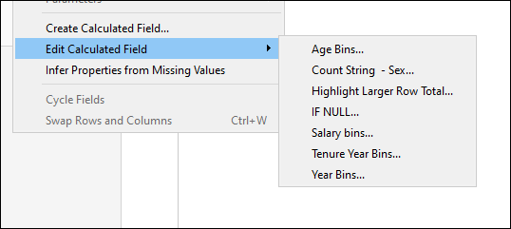

Total Number of Employees by Age Group and Sex

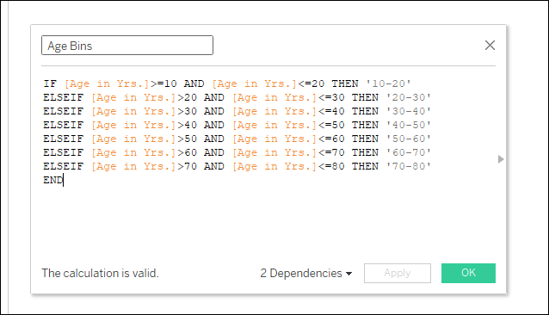

Total Number of Employees by Age Group and Sex

Number of Employees Hired by Sex in each Decade

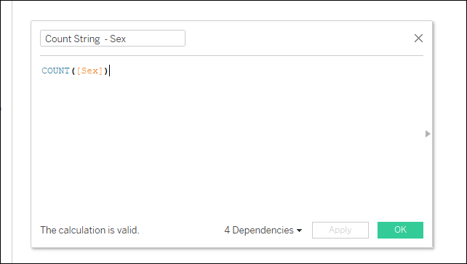

Employees Hired by Sex in each Decade

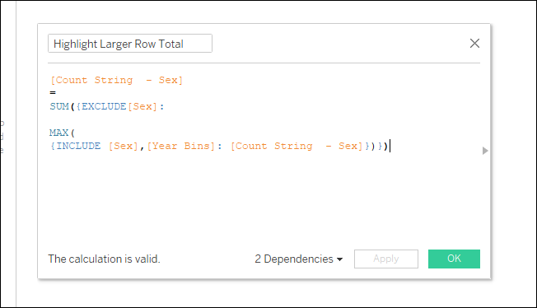

Tenure Totals for Employees

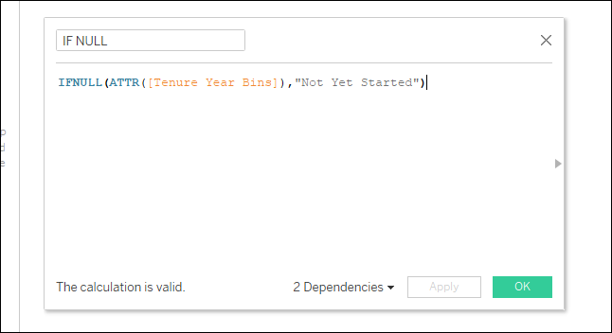

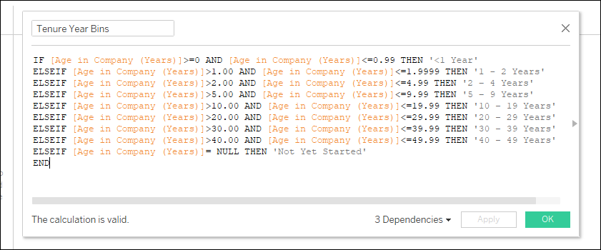

Number of Employees Hired by Sex in each Decade

